**Challenge1**

**Index.html**

<!DOCTYPE html>

<html lang="en">

<head>

    <meta charset="UTF-8">

    <meta http-equiv="X-UA-Compatible" content="IE=edge">

    <meta name="viewport" content="width=device-width, initial-scale=1.0">

    <title>Loops & Conditional statements</title>

</head>

<body>

    <script src="challenge1.js"></script>

</body>

</html>

**Challenge1.js**

const myObject={

    key1: true,

    key5: 10,

    key3: "abc",

    key4: null,

    key10: NaN

};

for(let key in myObject){

    if(key==="key1" || key==="key3"){

        console.log(myObject[key]);

    }

}

**Result**

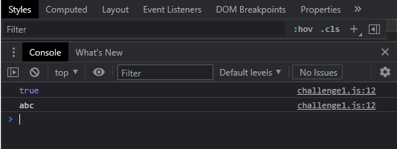

**Challenge2**

**Index.html**

<!DOCTYPE html>

<html lang="en">

<head>

    <meta charset="UTF-8">

    <meta http-equiv="X-UA-Compatible" content="IE=edge">

    <meta name="viewport" content="width=device-width, initial-scale=1.0">

    <title>Loops & Conditional statements</title>

</head>

<body>

    <script src="challenge2.js"></script>

</body>

</html>

**Challenge2.js**

function generateRandomNumber(min, max) {

    return Math.floor(min + Math.random()*(max + 1 - min))

  }

const myNumbers=[

    2355,7235,8135,1762,2361,8351

];

// let c=0;

do{

    var found=false;

    // c+=1;

    let newRandomNumber = generateRandomNumber(1000,9999);

    for(let num in myNumbers){

        if(num===newRandomNumber){

            found=true;

        }

    }

    if(found===false){

        myNumbers.push(newRandomNumber);

    }

}while(found);

console.log(myNumbers);

// console.log(c);

**Result**

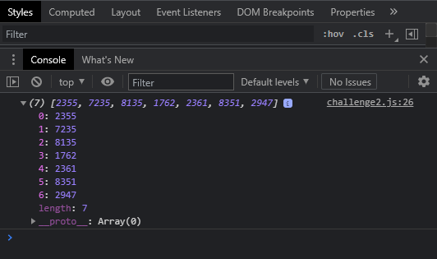

**Challenge3**

**Index.html**

<!DOCTYPE html>

<html lang="en">

<head>

    <meta charset="UTF-8">

    <meta http-equiv="X-UA-Compatible" content="IE=edge">

    <meta name="viewport" content="width=device-width, initial-scale=1.0">

    <title>Loops & Conditional statements</title>

</head>

<body>

    <script src="challenge3.js"></script>

</body>

</html>

**Challenge3.js**

const myObject={

    name: "Mike",

    age:30,

    city: "London"

};

Object.prototype.country="England";

for( let key in myObject ){

    if(myObject.hasOwnProperty(key)){

        console.log(myObject[key]);

    }

}

**Result**

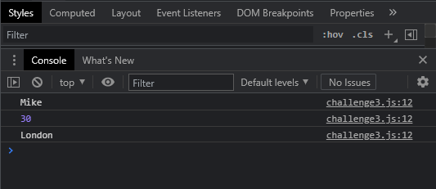

**Challenge4**

**Index.html**

<!DOCTYPE html>

<html lang="en">

<head>

    <meta charset="UTF-8">

    <meta http-equiv="X-UA-Compatible" content="IE=edge">

    <meta name="viewport" content="width=device-width, initial-scale=1.0">

    <title>Loops & Conditional statements</title>

</head>

<body>

    <script src="challenge4.js"></script>

</body>

</html>

**Challenge4.js**

function emptyArray(inputArray){

    return(inputArray.length > 0 ? "Array is not empty" : "Array is empty");

}

console.log(emptyArray([1,3]));

console.log(emptyArray([]));

**Result**

